# B.M.S. College of Engineering

(Autonomous College Affiliated to Visvesvaraya Technological University, Belgaum) Bull Temple Road, Basavanagudi, Bengaluru – 560019



**Department of**

**Computer Science & Engineering (CSE)**

# Couse Title: Object Oriented Java Programming

**BY**

**Diksha Nadiga (1BM22CS089)**

# B.M.S. College of Engineering

(Autonomous College Affiliated to Visvesvaraya Technological University, Belgaum) Bull Temple Road, Basavanagudi, Bengaluru – 560019



**Department of**

**Computer Science & Engineering (CSE)**

CERTIFICATE

This is to certify that the report on “**Java Lab Programs**” is a bona fide work carried out **Diksha Nadiga** bearing USN **1BM22CS089** as a part of an activity plan for the course **Object Oriented Java Programming**, Computer Science and Engineering from Visvesvaraya Technological University, Belgaum during the year 2023–24.

**Diksha Nadiga**

1BM22CS089 **Shravya AR**

Assistant Professor

Department of CSE

BMSCE, Bengaluru-19

LAB PROGRAM-1

Develop a Java program that prints all real solutions to the quadratic equation ax2+bx+c = 0. Read in a, b, c and use the quadratic formula. If the discriminate b2-4ac is negative, display a message stating that there are no real solutions.

import java**.**util**.**Scanner;

import java**.**lang**.**Math;

**class** q

{**public** **static** **void** main(String **XX**[])

 {

   System.out.println("NAME:DIKSHA NADIGA");

    System.out.println("USN:1BM22CS089");4

**int** a,b,c;

    System.out.println("enter the values of a,b,c respectively\n");

    Scanner s1= new Scanner(System.in);

    a = s1.nextInt();

    b = s1.nextInt();

    c = s1.nextInt();

**double** d= b*b - 4*a*c ;

    System.out.println("a = " + a +" b = " + b +" c = " + c);

    if(a==0) {System.out.println("not a quadratic equation");}

    else if( d>0)

    {

      System.out.println("the equation has two real and different solutions");

**double** r1=(-b + Math.sqrt(d))/(2*a);

**double** r2=(-b - Math.sqrt(d))/(2*a);

      System.out.println("r1 = " + r1);

      System.out.println("r2 = " + r2);

    }

   else if(d==0)

    {

      System.out.println("the equation has real and equal solutions");

**double** r1= -b/(2*a);

**double** r2= -b/(2*a);

      System.out.println("r1 = " + r1);

      System.out.println("r2 = " + r2);

    }

   else if(d<0)

    {

     System.out.println("the equation has unreal solutions");

    }

 }

}

**OUTPUT**

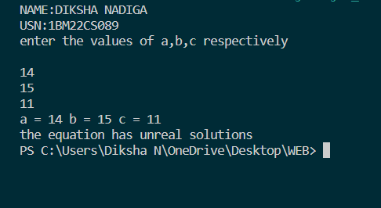

LAB PROGRAM-2

Write a Java program to create a class Student with members USN, name, marks(6 subjects). Include methods to accept student details and marks, Also include a method to calculate the percentage and display appropriate details. (Array of student object to be created)

import java**.**util**.**Scanner;

**class** Student{

   String usn;

   String name;

**int** marks[]= new **int**[6];

**void** Details()

   {

Scanner s=new Scanner(System.in);

System.out.println("Enter USN");

usn=s.next();

System.out.println("Enter Name");

name=s.next();

System.out.println("Enter marks for 6 subjects:");

for(**int** i = 0; i < 6; i++)

{

System.out.print("Subject " + (i + 1) + ": ");

marks[i]=s.nextInt();

}

   }

**double** percentage()

   {

**int** total=0;

for(**int** i=0;i<6;i++)

{

total+=marks[i];

}

**double** p=total/6;

return p;

   }

**void** display()

   {

System.out.println("\nStudent Details:");

        System.out.println("USN: " + usn);

        System.out.println("Name: " + name);

        System.out.println("Marks:");

        for(**int** i = 0; i < 6; i++)

        {

System.out.println("Subject " + (i + 1) + ": " + marks[i]);

        }

        System.out.println("Percentage: "+ percentage() + "%");

   }

}

**class** ma

{

**public** **static** **void** main(String args[]){

    System.out.println("NAME:DIKSHA NADIGA");

    System.out.println("USN:1BM22CS089");

Scanner s = new Scanner(System.in);

System.out.print("Enter the number of students: ");

**int** n = s.nextInt();

Student[] students = new Student[n];

for (**int** i = 0; i < n; i++)

{

students[i] = new Student();

System.out.println("\nEnter details for Student " + (i + 1) + ":");

students[i].Details();

}

for (Student student : students)

{

student.display();

}

}

}

**OUTPUT**

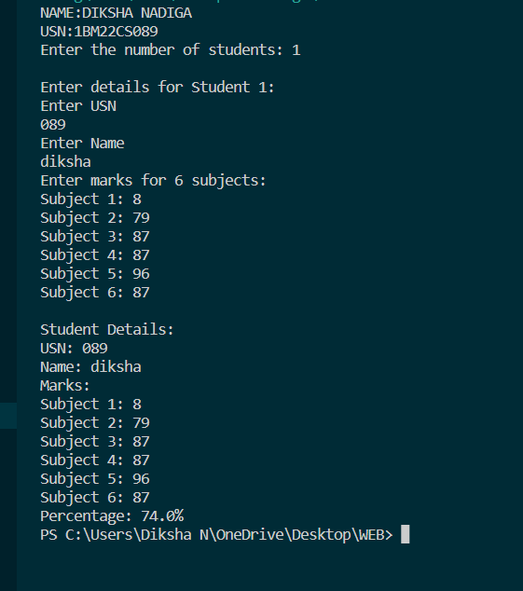

LAB PROGRAM-3

Create a class Book that contains four members: name, author, price, and num_pages. Include a constructor to set the values for the members. Include methods to set and get the details of the objects. Include a toString( ) method that could display the complete details of the book. Develop a Java program to create n book objects

import java**.**util**.**Scanner;

**class** Book{

    String Name;

    String Author;

**int** price;

**int** numPages;

    Book(String Name, String Author, **int** price, **int** numPages) {

        this.Name = Name;

        this.Author = Author;

        this.numPages = numPages;

        this.price = price;

    }

**public** String toString() {

        String name, author, price, numPages;

        name = "Book name: " + this.Name + "\n";

        author = "Author name: " + this.Author + "\n";

        numPages = "Number of pages: " + this.numPages + "\n";

        price = "Price: " + this.price + "\n";

        return name + author + numPages + price;

    }

}

**class** Main {

**public** **static** **void** main(String[] args) {

        System.out.println("NAME:DIKSHA NADIGA");

    System.out.println("USN:1BM22CS089");

        Scanner s = new Scanner(System.in);

**int** n;

        String Name;

        String Author;

**int** price;

**int** numPages;

        System.out.println("Enter the number of books");

        n = s.nextInt();

        Book b[] = new Book[n];

        for (**int** i = 0; i < n; i++) {

            System.out.println("book");

            System.out.println("Enter name of book");

            Name = s.next();

            System.out.println("Enter name of Author");

            Author = s.next();

            System.out.println("Enter price");

            price = s.nextInt();

            System.out.println("Enter numPages");

            numPages = s.nextInt();

            b[i] = new Book(Name, Author, price, numPages);

        }

        for (**int** i = 0; i < n; i++) {

            System.out.println("Books " + (i + 1) + "\n");

            System.out.println(b[i].toString());

        }

    }

}

**OUTPUT**

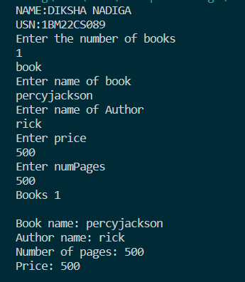

LAB PROGRAM-4

Develop a Java program to create an abstract class named Shape that contains two integers and an empty method named printArea( ). Provide three classes named Rectangle, Triangle and Circle such that each one of the classes extends the class Shape. Each one of the classes contain the method printArea( ) that prints the area of the given shape.

**abstract** **class** Shape {

**protected** **int** dimension1;

**protected** **int** dimension2;

**public** Shape(**int** dimension1, **int** dimension2) {

this.dimension1 = dimension1;

this.dimension2 = dimension2;

}

**public** **abstract** **void** printArea();

}

**class** Rectangle **extends** Shape {

**public** Rectangle(**int** length, **int** width) {

super(length, width);

}

**public** **void** printArea() {

**int** area = dimension1 * dimension2;

System.out.println("Area of Rectangle:"+ area);

}

}

**class** Triangle **extends** Shape {

**public** Triangle(**int** base, **int** height) {

super(base, height);

}

**public** **void** printArea() {

**double** area = 0.5 * dimension1 * dimension2;

System.out.println("Area of Triangle:" + area);

}

}

**class** Circle **extends** Shape {

**public** Circle(**int** radius) {

super(radius, 0);

}

**public** **void** printArea() {

**double** area = Math.PI * dimension1 * dimension1;

System.out.println("Area of Circle:" + area);

}

}

**public** **class** s {

**public** **static** **void** main(String[] args) {

    System.out.println("NAME:DIKSHA NADIGA");

    System.out.println("USN:1BM22CS089");

Rectangle rectangle = new Rectangle(4, 5);

rectangle.printArea();

Triangle triangle = new Triangle(3, 6);

triangle.printArea();

Circle circle = new Circle(7);

circle.printArea();

}

}

**OUTPUT**

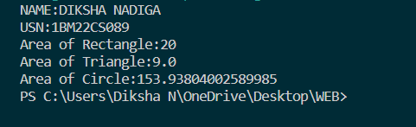

LAB PROGRAM-5

Develop a Java program to create a class Bank that maintains two kinds of account for its customers, one called savings account and the other current account. The savings account provides compound interest and withdrawal facilities but no cheque book facility. The current account provides cheque book facility but no interest. Current account holders should also maintain a minimum balance and if the balance falls below this level, a service charge is imposed.

Create a class Account that stores customer name, account number and type of account. From this derive the classes Cur-acct and Sav-acct to make them more specific to their requirements. Include the necessary methods in order to achieve the following tasks:

1. Accept deposit from customer and update the balance.
2. Display the balance.
3. Compute and deposit interest
4. Permit withdrawal and update the balance

Check for the minimum balance, impose penalty if necessary and update the balance.

**class** Bank {

**public** **static** **void** main(String[] args) {

    System.out.println("NAME:DIKSHA NADIGA");

    System.out.println("USN:1BM22CS089");

SavingsAccount savingsAccount = new SavingsAccount("John Doe" , "SA1001");

CurrentAccount currentAccount = new CurrentAccount("Jane Smith" , "CA2002");

savingsAccount.deposit(5000);

savingsAccount.displayBalance();

savingsAccount.computeInterest();

savingsAccount.displayBalance();

savingsAccount.withdraw(2000);

savingsAccount.displayBalance();

currentAccount.deposit(8000);

currentAccount.displayBalance();

currentAccount.withdraw(5000);

currentAccount.displayBalance();

}

}

**class** Account {

**protected** String customerName;

**protected** String accountNumber;

**protected** **double** balance;

**public** Account(String customerName, String accountNumber) {

this.customerName = customerName;

this.accountNumber = accountNumber;

this.balance = 0;

}

**public** **void** deposit(**double** amount) {

balance += amount;

System.out.println("Deposit of"  + amount +  "successful");

}

**public** **void** displayBalance() {

System.out.println("Account Number: " + accountNumber + "\nBalance:" + balance);

}

}

**class** SavingsAccount **extends** Account {

**public** SavingsAccount(String customerName, String accountNumber) {

super(customerName, accountNumber);

}

**public** **void** computeInterest() {

**double** interestRate = 0.05; *// Assuming a 5% interest rate*

**double** interest = balance * interestRate;

balance += interest;

System.out.println("Interest of " + interest +"computed and added to the balance");

}

**public** **void** withdraw(**double** amount) {

if (balance == amount) {

balance -= amount;

System.out.println("Withdrawal of " + amount + " successful");

} else {

System.out.println("Insufficient funds for withdrawal");

}

}

}

**class** CurrentAccount **extends** Account {

**private** **double** minimumBalance = 1000;

**public** CurrentAccount(String customerName, String accountNumber) {

super(customerName, accountNumber);

}

**public** **void** withdraw(**double** amount) {

if (balance - amount == minimumBalance) {

balance -= amount;

System.out.println("Withdrawal of "+ amount +"successful");

} else {

System.out.println("Insufficient funds. Service charge applied");

imposeServiceCharge();

}

}

**private** **void** imposeServiceCharge() {

**double** serviceCharge = 20;

balance -= serviceCharge;

System.out.println("Service charge of" + serviceCharge + " imposed");

}

}

**OUTPUT**

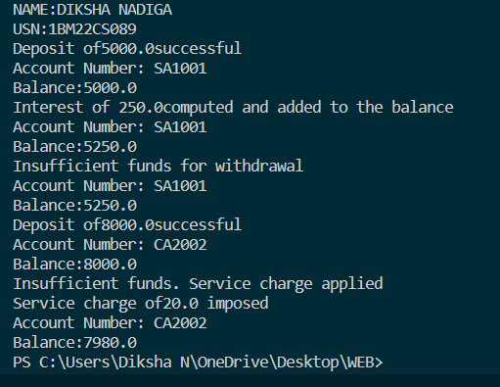

LAB PROGRAM-6

Create a package CIE which has two classes- Student and Internals. The class Student has members like usn, name, sem. The class internals derived from student has an array that stores the internal marks scored in five courses of the current semester of the student. Create another package SEE which has the class External which is a derived class of Student. This class has an array that stores the SEE marks scored in five courses of the current semester of the student. Import the two packages in a file that declares the final marks of n students in all five courses.  
1. Create a folder CIE and save the programs Student.java and Internals.java within it.  
2. Create a folder SEE and save the program External.java within it.  
3. Save the Main program outside these two folders.  
4. Compile Main.java and Execute the Main.class

MAIN

import cie.Internals;

import see.External;

import java.util.Scanner;

public class Main {

public static void main(String[] args) {

System.out.println("Enter the number of students");

Scanner input = new Scanner(System.in);

int n = input.nextInt();

Internals[] s1 = new Internals[n];

External[] s2 = new External[n];

int[] finalcie = new int[n];

int[] finalsee = new int[n];

for (int i = 0; i < n; i++) {

s1[i] = new Internals();

System.out.println("Enter the name");

s1[i].name = input.next();

System.out.println("Enter the usn");

s1[i].usn = input.next();

System.out.println("Enter the sem");

s1[i].sem = input.nextInt();

System.out.println("Enter the marks of 5 subjects");

for (int j = 0; j < 5; j++) {

s1[i].marks[j] = input.nextInt();

finalcie[i] += s1[i].marks[j];

}

}

for (int i = 0; i < n; i++) {

s2[i] = new External();

System.out.println("Enter the name");

s2[i].name = input.next();

System.out.println("Enter the usn");

s2[i].usn = input.next();

System.out.println("Enter the sem");

s2[i].sem = input.nextInt();

System.out.println("Enter the marks of 5 subjects");

for (int j = 0; j < 5; j++) {

s2[i].seemarks[j] = input.nextInt();

finalsee[i] += s2[i].seemarks[j];

}

}

System.out.println("Final marks:");

for (int i = 0; i < n; i++) {

System.out.println("Name: " + s1[i].name + " USN: " + s1[i].usn + " Sem: " + s1[i].sem);

System.out.println("Internal marks: " + finalcie[i]);

System.out.println("External marks: " + finalsee[i]);

System.out.println("Total marks: " + (finalcie[i] + finalsee[i]));

}

}

}

EXTERNAL

package see;

import cie.Student;

public class External extends Student{

public int[] seemarks=new int[5];

}

INTERNALS

package cie;

public class Internals extends Student{

public int[] marks=new int[5];

}

STUDENT

package cie;

public class Student{

public String name;

public String usn;

public int sem;

}

**OUTPUT**

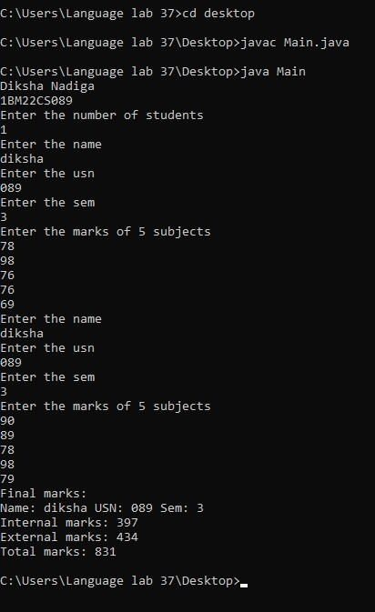

LAB PROGRAM-7

Write a program that demonstrates handling of exceptions in inheritance tree. Create a base class called “Father” and derived class called “Son” which extends the base class. In Father class, implement a constructor which takes the age and throws the exception WrongAge( ) when the input age<0. In Son class, implement a constructor that cases both father and son’s age and throws an exception if son’s age is >=father’s age.

**class** WrongAge **extends** Exception {

**public** WrongAge(String message) {

        super(message);

    }

}

**class** Father {

**int** age;

**public** Father(**int** age) **throws** WrongAge {

        if (age < 0) {

            throw new WrongAge("Age cannot be negative");

        }

        this.age = age;

    }

**public** **int** getAge() {

        return age;

    }

}

**class** Son **extends** Father {

**int** sonAge;

**public** Son(**int** fatherAge, **int** sonAge) **throws** WrongAge {

        super(fatherAge);

        if (sonAge >= fatherAge) {

            throw new WrongAge("Son's age cannot be greater than or equal to father's age");

        }

        this.sonAge = sonAge;

    }

**public** **int** getSonAge() {

        return sonAge;

    }

}

**public** **class** f{

**public** **static** **void** main(String[] args) {

        System.out.println("NAME:DIKSHA NADIGA");

        System.out.println("USN:1BM22CS089");

        try {

            Father father = new Father(45);

            System.out.println("Father's age: " + father.getAge());

            Son son = new Son(45, 20); *// This will throw an exception*

            System.out.println("Son's age: " + son.getSonAge());

        } catch (WrongAge e) {

            System.out.println("Exception caught: " + e.getMessage());

        }

    }

**OUTPUT**

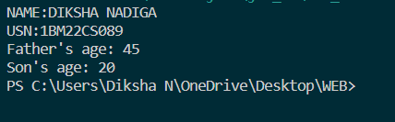

LAB PROGRAM-8

Write a program which creates two threads, one thread displaying “BMS College of Engineering” once every ten seconds and another displaying “CSE” once every two seconds.

**class** DispMessage **extends** Thread {

    String message;

**int** interval; *// Interval in milliseconds*

**public** DispMessage(String message, **int** interval) {

        this.message = message;

        this.interval = interval;

    }

**public** **void** run() {

        while (true) {

            System.out.println(message);

            try {

                Thread.sleep(interval); *// Sleep for the specified interval*

            } catch (InterruptedException e) {

                e.printStackTrace();

            }

        }

    }

}

**public** **class** fs {

**public** **static** **void** main(String[] args) {

           System.out.println("NAME:DIKSHA NADIGA");

        System.out.println("USN:1BM22CS089");

        DispMessage bmsThread = new DispMessage("BMS College of Engineering", 10000); *// 10 seconds*

        DispMessage cseThread = new DispMessage("CSE", 2000); *// 2 seconds*

        bmsThread.start();

        cseThread.start();

    }

}

**OUTPUT**

